Interior design is both an art and a science, aiming to enhance the interiors of a space to achieve a healthier and more aesthetically pleasing environment. Central to this discipline are the elements and principles of design. While they are interconnected and often overlap, understanding the distinction between them is an integral part of any aspiring interior designer’s basic knowledge.

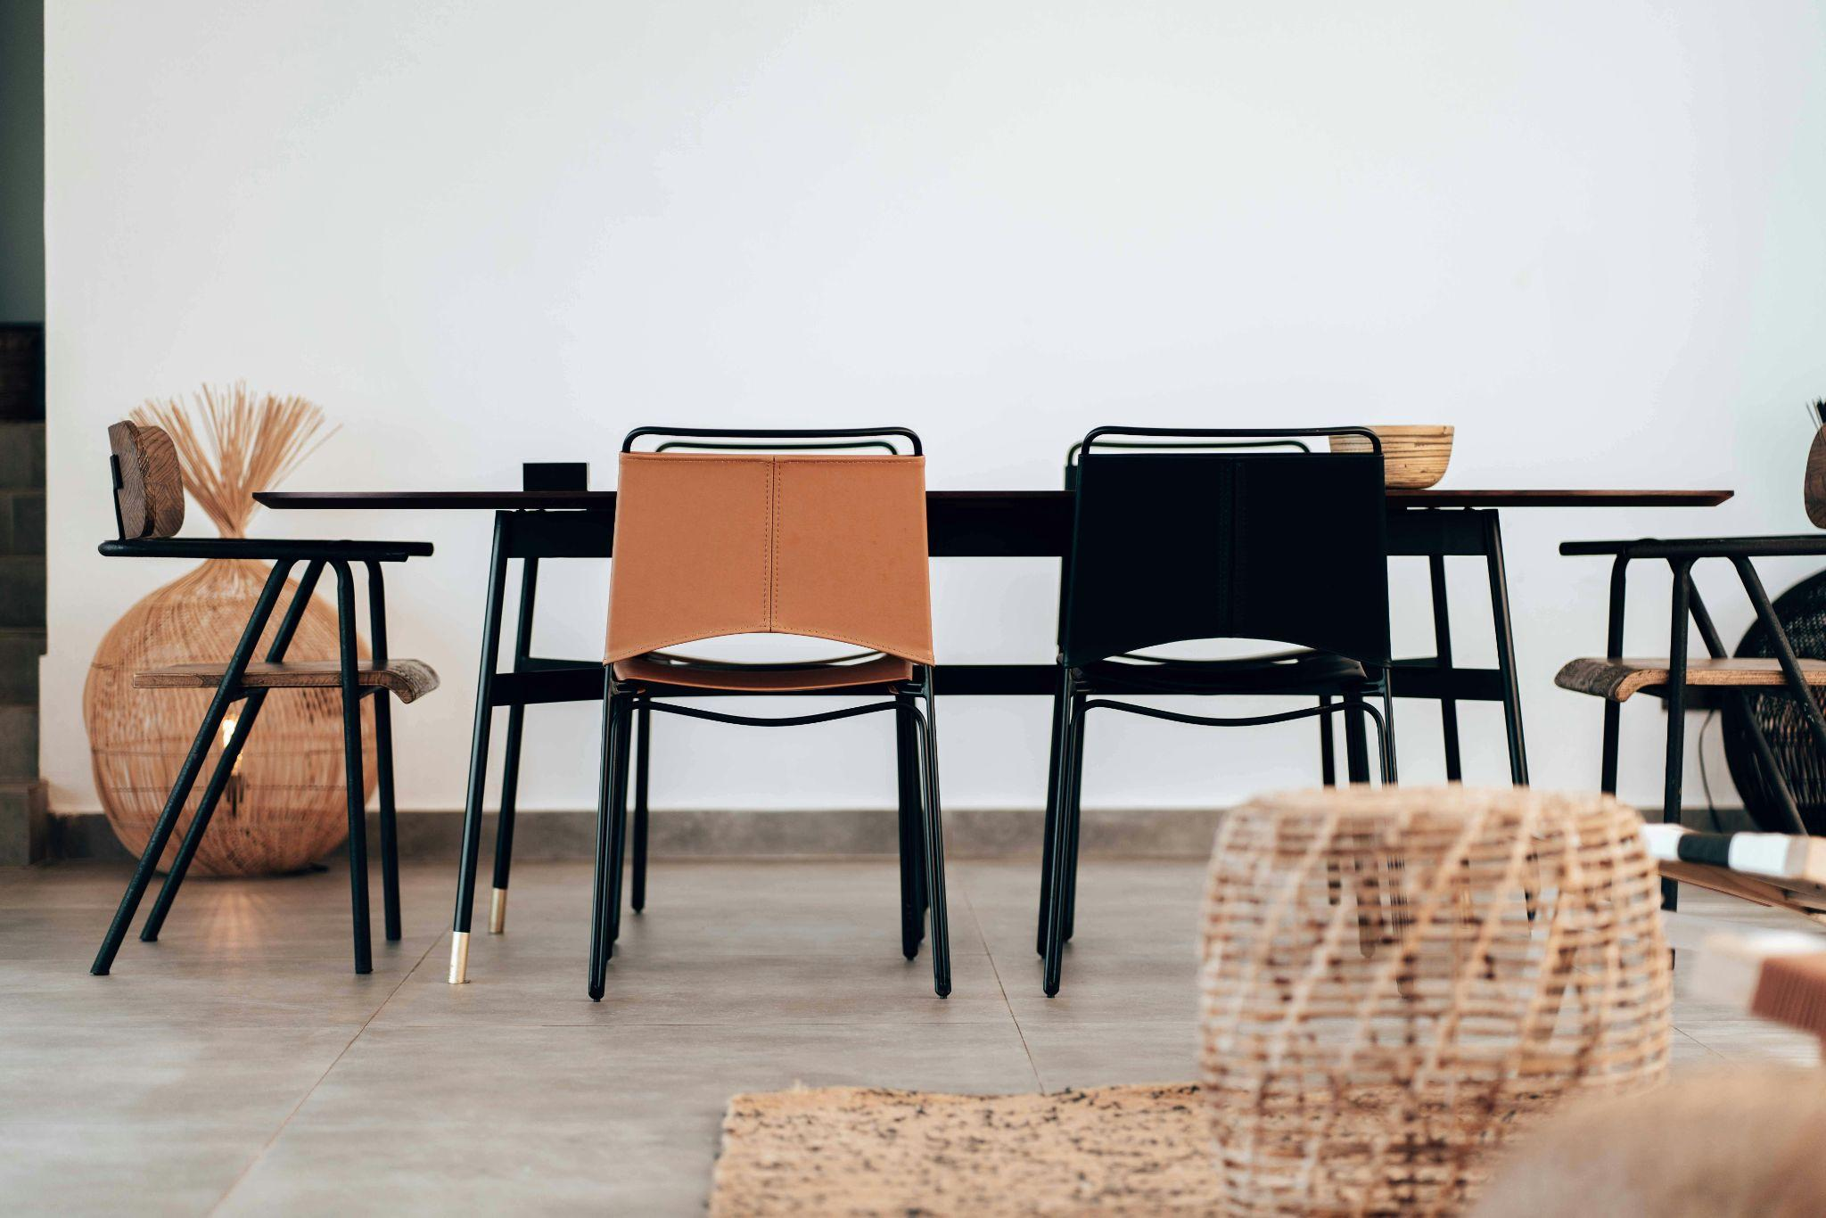

Fig. 1. Pexels (n.d.), Brown and Black Chair Beside Table

# Elements of Interior Design

Elements of design are the fundamental components that designers use in order to create a visually appealing and functional space. These elements work together to form the foundation of any interior design project. They include:

1. **Colour:** Colour influences mood and perception more than any other element. It can make a space feel larger, cosier, warmer, or cooler. Understanding colour theory and how colours interact is vital for effective design.
2. **Light:** An essential element that impacts the ambiance and functionality of a space. Natural light, artificial light, and the interplay between them, can dramatically affect the perception of colour, texture, and space.
3. **Line:** Lines guide the eye, and define shapes and forms. They can be vertical, horizontal, or dynamic (such as diagonal or curved lines). Each type of line evokes a different feeling or response in the space.
4. **Form**: Looks at the shape of the room as well as the objects within it. Forms can be geometric (e.g. squares, rectangles) or organic (e.g. natural shapes). Forms must be harmonious with each other and the overall design theme.
5. **Texture**: Refers to the surface quality of materials, which can be visual or tactile. Mixing different textures can add depth and interest to a space. For example, smooth surfaces like glass contrast with rougher textures like brick.
6. **Pattern**: Patterns add interest and life to a space. They can be found in wallpapers, fabrics, rugs, and other design elements. The scale and style of patterns should be in harmony with the overall design.
7. **Space**: Refers to the physical boundaries of a room. It can be divided into positive space (filled with objects) and negative space (empty areas). Understanding how to balance these spaces is essential for creating a cohesive design.

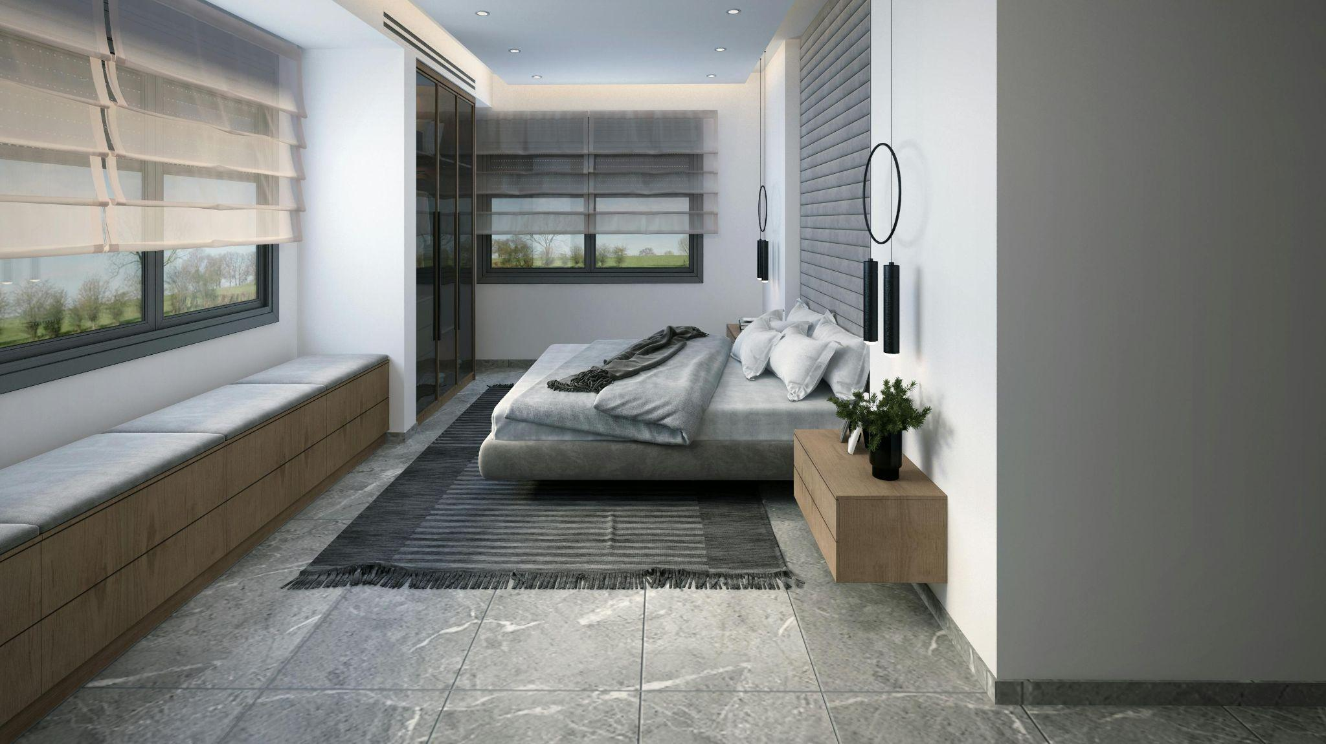

Fig. 2. Pexels (n.d.), Interior Space with various Textures and Lines

# Principles of Interior Design

The principles of design are the guidelines that inform how the elements are used to create a harmonious and effective design. These principles ensure that the elements work cohesively together. They include:

* 1. **Balance**: Refers to the distribution of visual weight within a space. It can be symmetrical (formal balance), asymmetrical (informal balance), or radial (elements are placed in a circular motion, around a central point). Proper balance creates stability and harmony.
  2. **Rhythm**: Creates a sense of movement and flow within a space. Rhythm can be achieved through repetition, progression, or alteration. It helps guide the eye through the room and creates a cohesive experience.
  3. **Scale**: Refers to the size of an object in relation to the space it occupies, or to the size of other objects in the same space. Proper scale ensures that furnishings and decor fit well within the room and are proportionate to human dimensions.
  4. **Focal Point**: Draws attention to a particular area or object within a space. This can be achieved through the use of colour, light, decor and artworks, or architectural features. A focal point ensures that important elements stand out and capture interest.
  5. **Proportion**: Refers to the relationship between the sizes of different parts of a design or composition. It ensures that elements within a space relate well to each other. For example, a coffee table should be proportional to the sofa it accompanies.
  6. **Dominance**: Establishes a hierarchy within the design, highlighting the most important elements and ensuring they stand out. Dominance guides the viewer’s attention and helps organise the visual arrangement of a space.
  7. **Contrast**: Focuses on the juxtaposition of opposing elements (such as light vs. dark, rough vs. smooth), in order to create visual interest and dynamic compositions. Contrast adds excitement and draws attention to key elements.

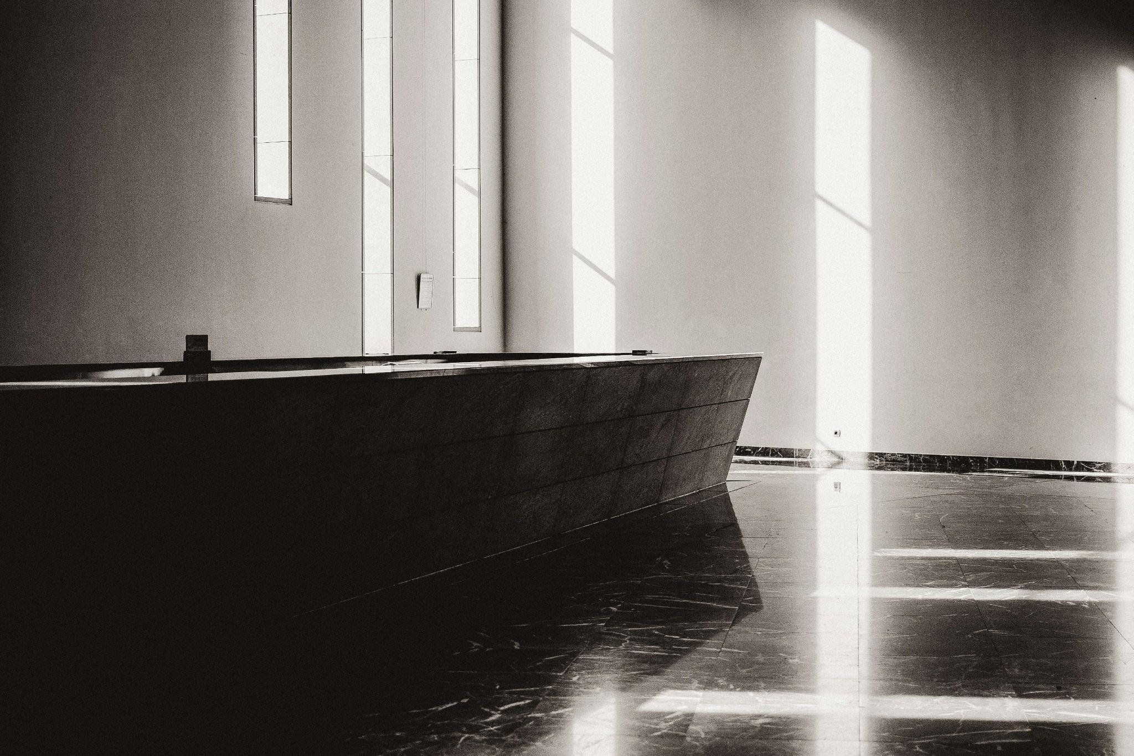

Fig. 3. Pexels (n.d.), Interior of Bathroom with Black Bath

# Differences Between Elements and Principles

While both Elements and Principles are fundamental to interior design, they serve different purposes:

Elements of Design are the tangible components used to create a space. They are the "what" of the design process. Think of them as the ingredients in a recipe.

Principles of Design are the "how" — they guide how the elements are applied to achieve a successful design. They are the methods and strategies that ensure the elements are used effectively, much like the instructions in a recipe.

In summary, elements are the basic components that make up the design, and principles are the rules and guidelines that dictate how these components are arranged and utilised. Having a solid understanding of both of these will assist you in creating spaces that are not only functional, but also aesthetically pleasing and emotionally resonant.